**Id code:** 19CM029  **Name:** DhirajM. Jagtap **Sem:** 5th

**Practical No: 3**

**Aim:** Write a PHP program to demonstrate the use of Looping structures using-

a) While statement

b) Do-while statement

c) For statement

d) Foreach statement

1. **While statement**:

* Theory:

PHP while loop can be used to traverse set of code like for loop. The while loop executes a block of code repeatedly until the condition is FALSE. Once the condition gets FALSE, it exits from the body of loop.

It should be used if the number of iterations is not known.

The while loop is also called an Entry control loop because the condition is checked before entering the loop body. This means that first the condition is checked. If the condition is true, the block of code will be executed.

* Syntax:

While loop

while (condition is true)

{

//code to be executed;

}

* Program:

<?php

 $name = "Dhiraj";

 $a = 1 ;

    while ($a<2500) {

        echo $name;

        $a++;

        echo " ";

    }

?>

* Output:

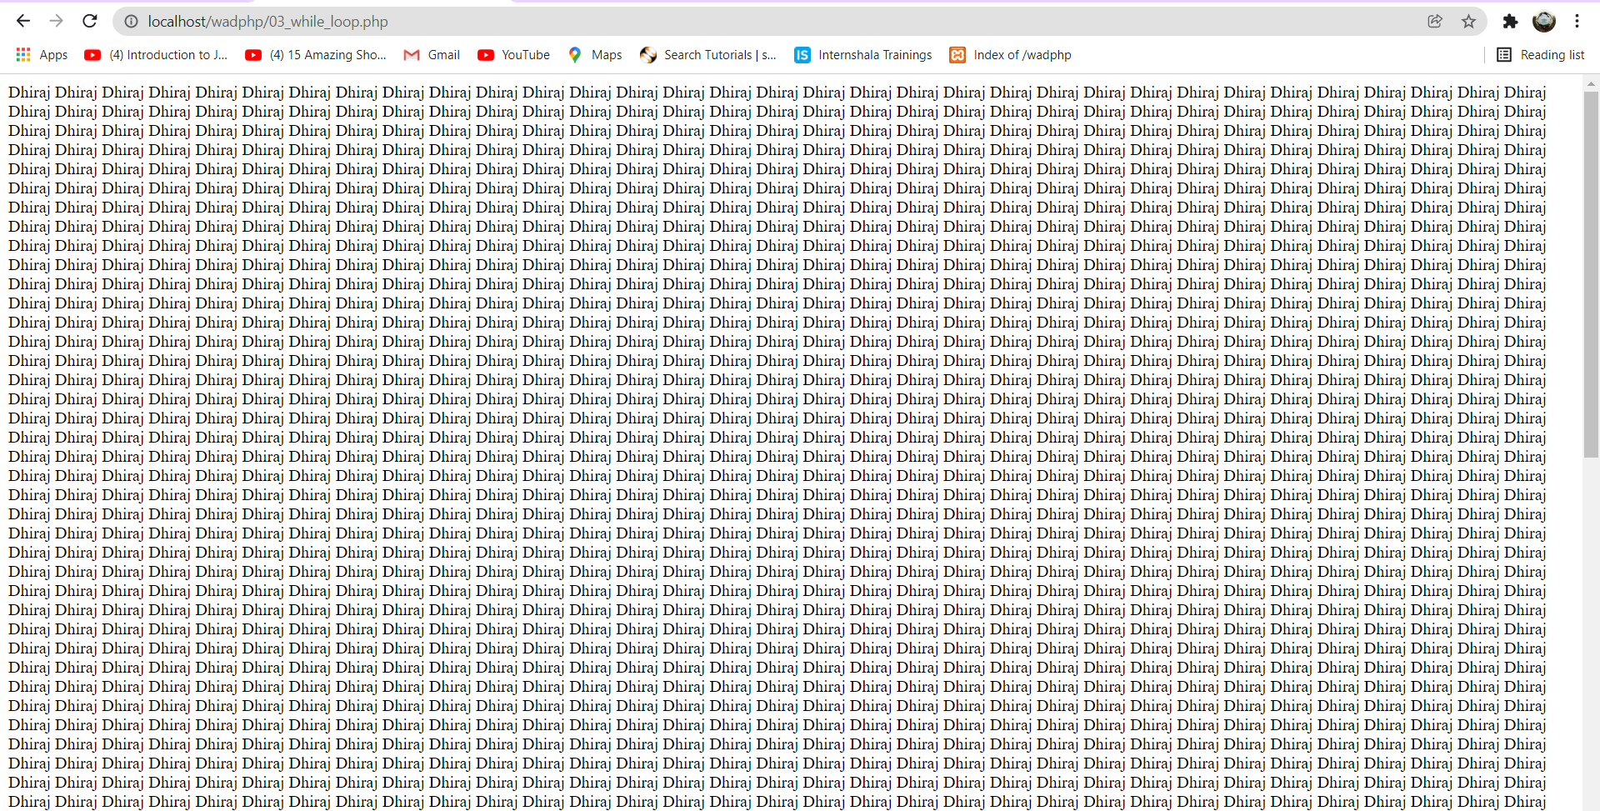

1. Do-while statement:

* Theory:

PHP do-while loop can be used to traverse set of code like php while loop. The PHP do-while loop is guaranteed to run at least once. The PHP do-while loop is used to execute a set of code of the program several times. If you have to execute the loop at least once and the number of iterations is not even fixed, it is recommended to use the **do-while** loop. It executes the code at least one time always because the condition is checked after executing the code. The do-while loop is very much similar to the while loop except the condition check. The main difference between both loops is that while loop checks the condition at the beginning, whereas do-while loop checks the condition at the end of the loop.

* Syntax:

do

{

//code to be executed;

} while (condition is true);

* Program:

<?php

//write a program to print 'Welcome to Amravati 3000 times'

$a = 1;

do {

    echo "Welcome to Amravati ". $a;

    echo " ";

    $a++;

}while ($a < 30000);

?>

* Output:  
  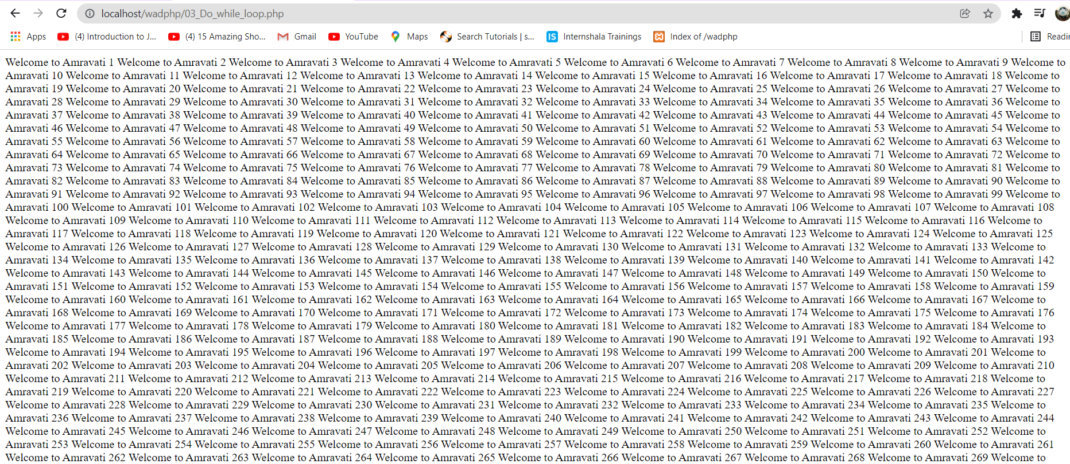

1. **For statement:**

* Theory:

PHP for loop can be used to traverse set of code for the specified number of times.

It should be used if the number of iterations is known otherwise use while loop. This means for loop is used when you already know how many times you want to execute a block of code.

* Syntax:

for(initialization; condition; increment/decrement){

//code to be executed

}

* Program:

<?php

    $i;

    //print GPA 4000

    for ($i=0; $i<4000; $i++) {

        echo "  GPA  ";

    }

?>

* Output:

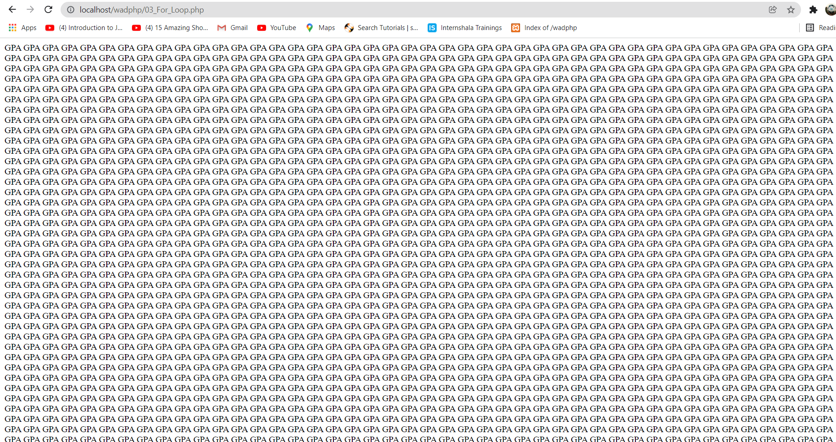

1. **For Each Statement:**

* Theory:

PHP for each loop is used to traverse array elements.

* Syntax:

foreach( $array as $var ){

//code to be executed

}

?>

* Program:

<?php

$Branch=array("Computer","IT","Civil","Mechanical","Electrical");

foreach( $Branch as $arr ){

  echo "The Bracnh is: $arr<br/>";

}

?>

* Output:

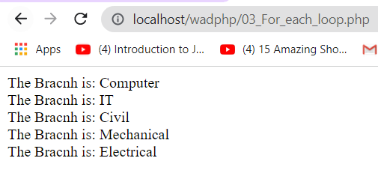

**Conclusion:** hence, we have performed various practicals on looping in <?Php?>